Test FE  
Summer 2022  
Subject: WED201c  
Duration: 120 minutes

**Objectives:**

* Create a style sheet file and link it to the html file.

**Background:**

In this practice exam, you are given a folder “**Resource**”. You are going to use page “index.html” and images in folder “images” to finish the exam. **You don’t be used bootstrap framework.**

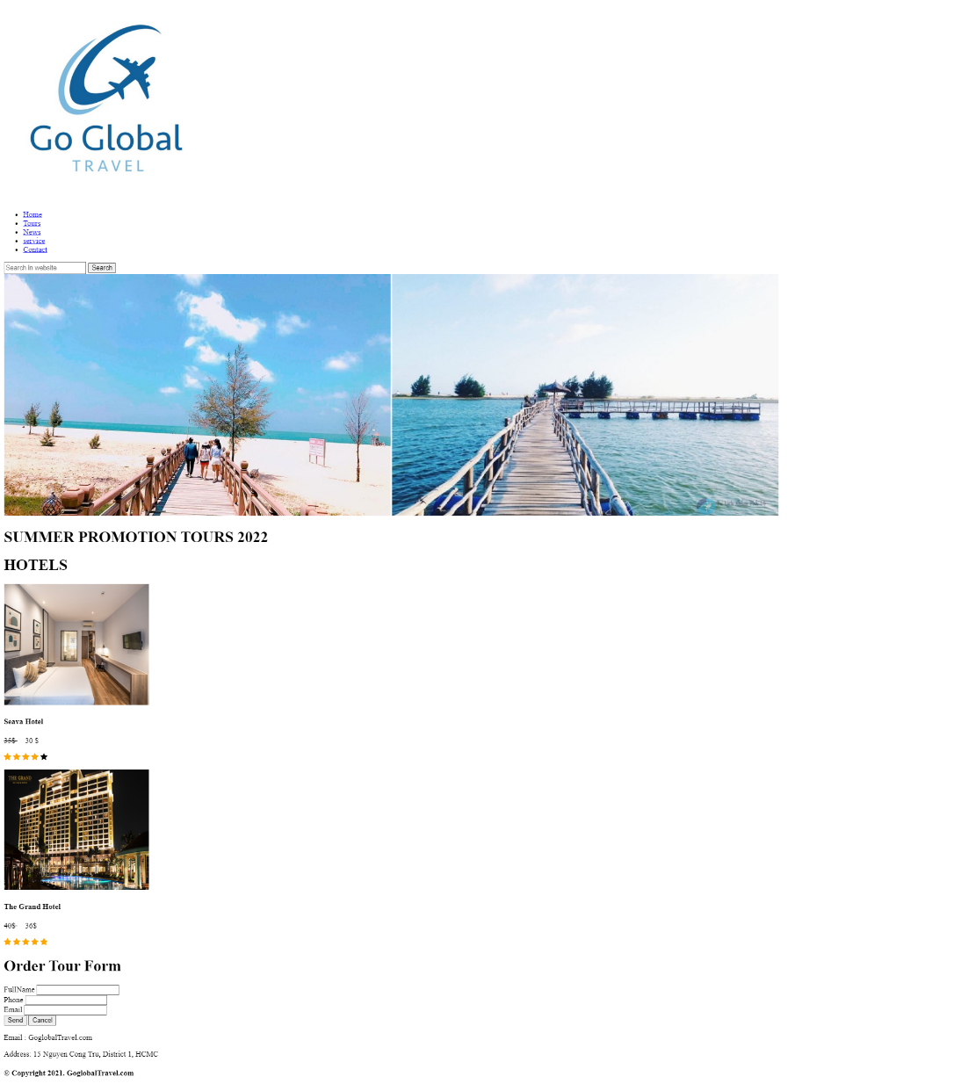**Before styling index.html page**

**After styling index.html page**

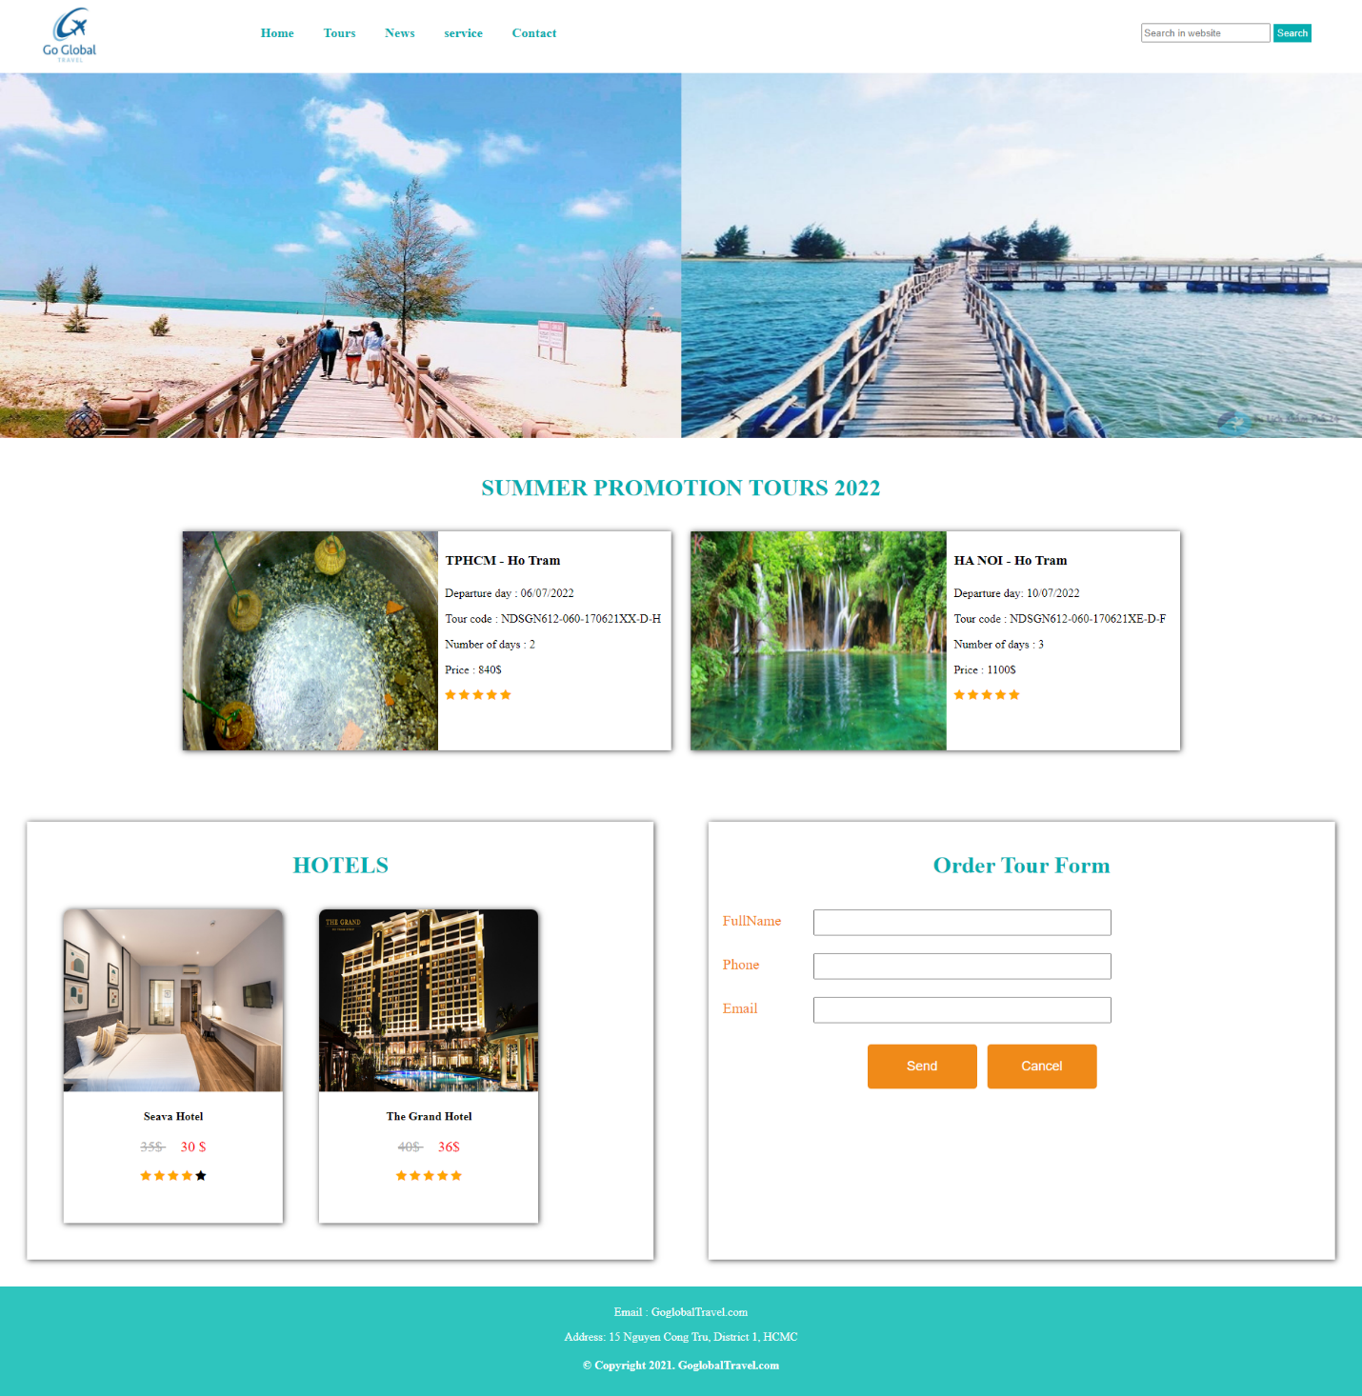

**Required:**

1. Create a file called styleindex.css to format the index.html page and save it to the **Resource/css folder**.

**Evaluation**

**A. HTML [3 marks]**

* Embed the styleindex.css file in the head tag of the index.html page [0.5 points].
* Insert the “SUMMER PROMOTION TOURS 2022” content as shown above [ 1.5 points].

**B. CSS [ 8 marks]**

* Use margin and padding to create the right spacing for the content [1 points].
* Use css to format the logo and search as shown above [ 1 points].
* Use css to format the menu as shown above [ 1 points].
* Use css to format the banner as shown above [ 0.5 points].
* Use color to format content titles [ 0.5 point].
* Use css to format “SUMMER PROMOTION TOURS 2022” the content [1 points].
* Use color and background to format for the “footer” content [1 points].
* Use width, height to format images as shown above [1 points].
* Use css to format for the “Order Tour Form” content [ 1 points].

**The end**